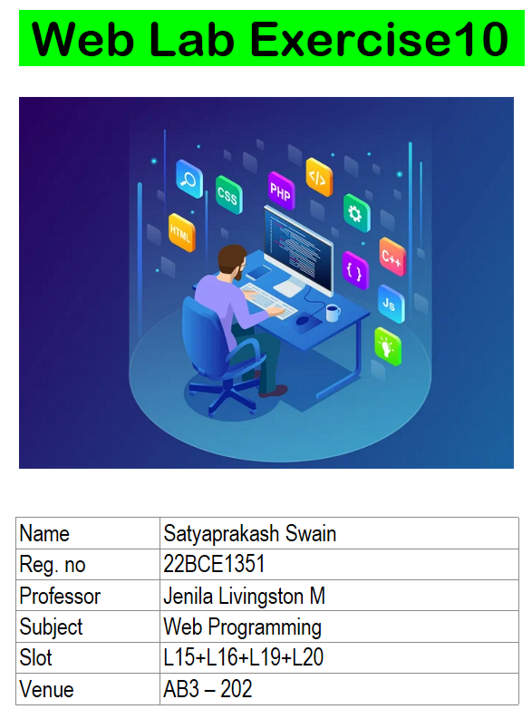

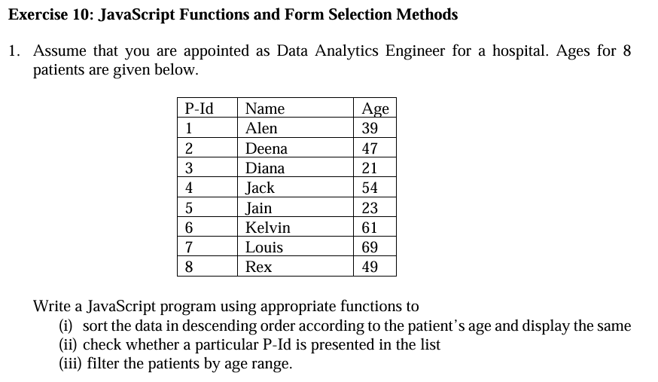

// Patient Data

const patients = [

    { P_Id: 1, Name: "Alen", Age: 39 },

    { P_Id: 2, Name: "Deena", Age: 47 },

    { P_Id: 3, Name: "Diana", Age: 21 },

    { P_Id: 4, Name: "Jack", Age: 54 },

    { P_Id: 5, Name: "Jain", Age: 23 },

    { P_Id: 6, Name: "Kelvin", Age: 61 },

    { P_Id: 7, Name: "Louis", Age: 69 },

    { P_Id: 8, Name: "Rex", Age: 49 }

];

// (i) Sort patients in descending order by age

function sortByAgeDesc(patients) {

    return patients.sort((a, b) => b.Age - a.Age);

}

// (ii) Check if a P-Id exists in the list

function isPatientPresent(patients, id) {

    return patients.some(patient => patient.P_Id === id);

}

// (iii) Filter patients within an age range

function filterByAgeRange(patients, minAge, maxAge) {

    return patients.filter(patient => patient.Age >= minAge && patient.Age <= maxAge);

}

// Testing the functions

console.log("Sorted Patients by Age (Descending):");

console.log(sortByAgeDesc([...patients])); // Copy to avoid modifying original array

console.log("\nIs P-Id 4 present?", isPatientPresent(patients, 4));

console.log("Is P-Id 10 present?", isPatientPresent(patients, 10));

console.log("\nPatients aged between 40 and 60:");

console.log(filterByAgeRange(patients, 40, 60));

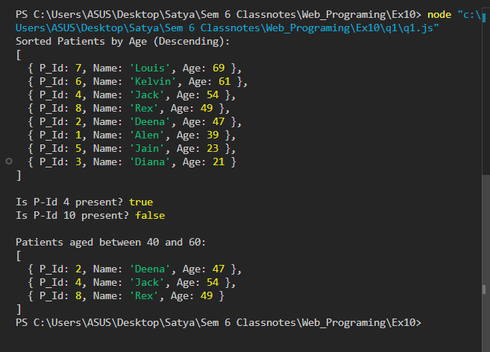

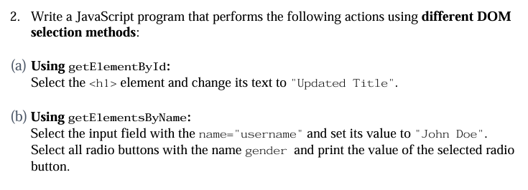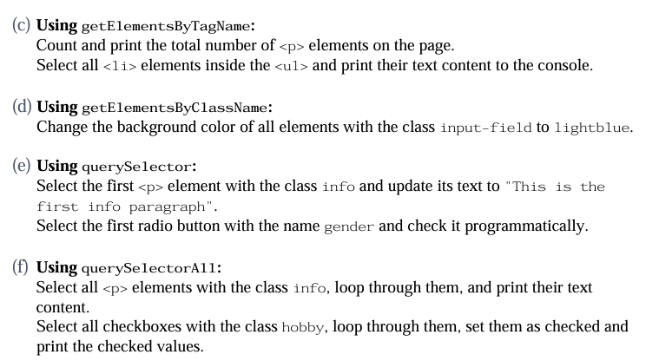

<!DOCTYPE html>

<html lang="en">

<head>

    <meta charset="UTF-8">

    <meta name="viewport" content="width=device-width, initial-scale=1.0">

    <title>DOM Selection Methods</title>

    <style>

        .input-field { padding: 5px; border: 1px solid black; }

    </style>

</head>

<body>

    <!-- (a) getElementById -->

    <h1 id="main-title">Original Title</h1>

    <!-- (b) getElementsByName -->

    <input type="text" name="username" placeholder="Enter name">

    <br><br>

    <label>Gender:</label>

    <input type="radio" name="gender" value="Male"> Male

    <input type="radio" name="gender" value="Female"> Female

    <input type="radio" name="gender" value="Other"> Other

    <br><br>

    <!-- (c) getElementsByTagName -->

    <p>Paragraph 1</p>

    <p>Paragraph 2</p>

    <p>Paragraph 3</p>

    <ul>

        <li>Item 1</li>

        <li>Item 2</li>

        <li>Item 3</li>

    </ul>

    <!-- (d) getElementsByClassName -->

    <input type="text" class="input-field" placeholder="Field 1">

    <input type="text" class="input-field" placeholder="Field 2">

    <br><br>

    <!-- (e) querySelector -->

    <p class="info">Info paragraph 1</p>

    <p class="info">Info paragraph 2</p>

    <p class="info">Info paragraph 3</p>

    <!-- (f) querySelectorAll -->

    <label>Hobbies:</label>

    <input type="checkbox" class="hobby" value="Reading"> Reading

    <input type="checkbox" class="hobby" value="Traveling"> Traveling

    <input type="checkbox" class="hobby" value="Sports"> Sports

    <br><br>

    <script>

        // (a) Using getElementById - Change h1 text

        document.getElementById("main-title").textContent = "Updated Title";

        // (b) Using getElementsByName

        // Set the value of the input field

        document.getElementsByName("username")[0].value = "John Doe";

        // Get all radio buttons with name="gender" and print selected value

        const genderRadios = document.getElementsByName("gender");

        for (let radio of genderRadios) {

            if (radio.checked) {

                console.log("Selected Gender:", radio.value);

            }

        }

        // (c) Using getElementsByTagName

        // Count and print total <p> elements on the page

        const paragraphs = document.getElementsByTagName("p");

        console.log("Total number of <p> elements on the page:", paragraphs.length);

        // Print all <li> elements inside <ul>

        const listItems = document.getElementsByTagName("li");

        for (let item of listItems) {

            console.log("List Item:", item.textContent);

        }

        // (d) Using getElementsByClassName

        // Change background color of all .input-field elements

        const inputFields = document.getElementsByClassName("input-field");

        for (let field of inputFields) {

            field.style.backgroundColor = "lightblue";

        }

        // (e) Using querySelector

        // Select first <p> with class "info" and update text

        document.querySelector(".info").textContent = "This is the first info paragraph";

        // Select first radio button with name="gender" and check it

        document.querySelector("input[name='gender']").checked = true;

        // (f) Using querySelectorAll

        // Select all <p> with class "info" and print text

        document.querySelectorAll(".info").forEach(p => console.log("Info Paragraph:", p.textContent));

        // Select all checkboxes with class "hobby", check them and print checked values

        document.querySelectorAll(".hobby").forEach(checkbox => {

            checkbox.checked = true;

            console.log("Checked Hobby:", checkbox.value);

        });

    </script>

</body>

</html>

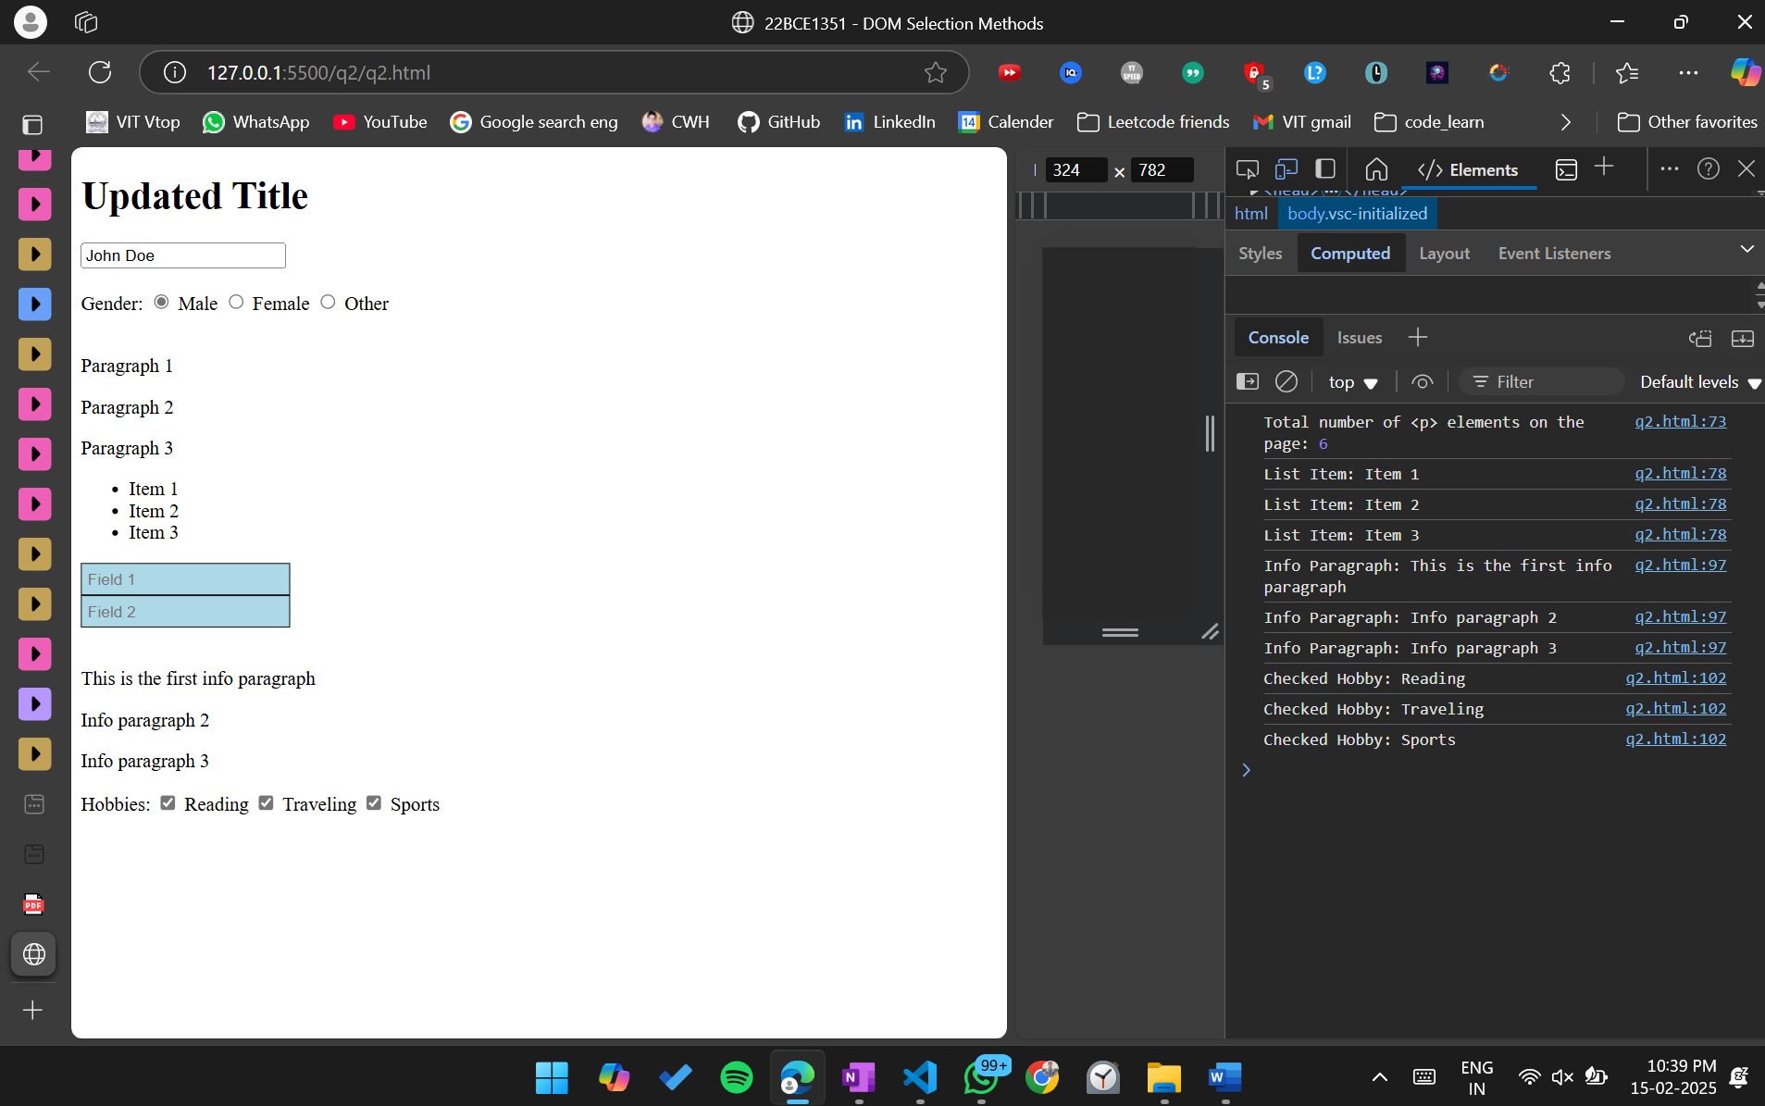

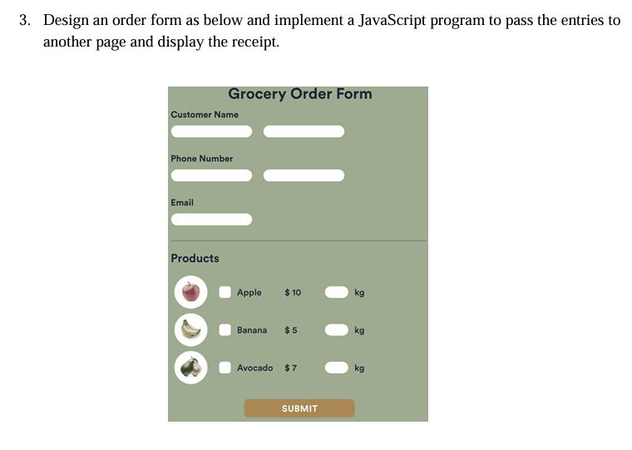

Index.html

<!DOCTYPE html>

<html lang="en">

<head>

    <meta charset="UTF-8">

    <meta name="viewport" content="width=device-width, initial-scale=1.0">

    <title>Grocery Order Form</title>

    <style>

        body {

            font-family: Arial, sans-serif;

            background-color: #a0a78c;

            display: flex;

            justify-content: center;

            align-items: center;

            height: 100vh;

        }

        .container {

            background: #6e755f;

            padding: 20px;

            border-radius: 10px;

            color: white;

            width: 300px;

        }

        .input-field, .quantity {

            width: 100%;

            padding: 5px;

            margin: 5px 0;

        }

        .product {

            display: flex;

            align-items: center;

            justify-content: space-between;

        }

        .submit-btn {

            background: #b88d5b;

            border: none;

            padding: 10px;

            width: 100%;

            color: white;

            font-size: 16px;

            cursor: pointer;

        }

    </style>

</head>

<body>

    <div class="container">

        <h2>Grocery Order Form</h2>

        <form id="orderForm">

            <label>Customer Name:</label>

            <input type="text" id="name" class="input-field" required>

            <label>Phone Number:</label>

            <input type="text" id="phone" class="input-field" required>

            <label>Email:</label>

            <input type="email" id="email" class="input-field" required>

            <h3>Products</h3>

            <div class="product">

                <input type="checkbox" id="apple" value="Apple" class="product-checkbox">

                <label for="apple">Apple ($10/kg)</label>

                <input type="number" id="appleQty" class="quantity" min="0" value="0">

            </div>

            <div class="product">

                <input type="checkbox" id="banana" value="Banana" class="product-checkbox">

                <label for="banana">Banana ($5/kg)</label>

                <input type="number" id="bananaQty" class="quantity" min="0" value="0">

            </div>

            <div class="product">

                <input type="checkbox" id="avocado" value="Avocado" class="product-checkbox">

                <label for="avocado">Avocado ($7/kg)</label>

                <input type="number" id="avocadoQty" class="quantity" min="0" value="0">

            </div>

            <button type="submit" class="submit-btn">Submit</button>

        </form>

    </div>

    <script>

        document.getElementById("orderForm").addEventListener("submit", function(event) {

            event.preventDefault();

            const name = document.getElementById("name").value;

            const phone = document.getElementById("phone").value;

            const email = document.getElementById("email").value;

            const orderDetails = [];

            const products = [

                { name: "Apple", price: 10, qty: document.getElementById("appleQty").value, checked: document.getElementById("apple").checked },

                { name: "Banana", price: 5, qty: document.getElementById("bananaQty").value, checked: document.getElementById("banana").checked },

                { name: "Avocado", price: 7, qty: document.getElementById("avocadoQty").value, checked: document.getElementById("avocado").checked }

            ];

            products.forEach(product => {

                if (product.checked && product.qty > 0) {

                    orderDetails.push(`${product.name}:${product.qty}:${product.price}`);

                }

            });

            const queryString = `name=${encodeURIComponent(name)}&phone=${encodeURIComponent(phone)}&email=${encodeURIComponent(email)}&order=${encodeURIComponent(orderDetails.join(","))}`;

            window.location.href = `receipt.html?${queryString}`;

        });

    </script>

</body>

</html>

Receipt.html

<!DOCTYPE html>

<html lang="en">

<head>

    <meta charset="UTF-8">

    <meta name="viewport" content="width=device-width, initial-scale=1.0">

    <title>Order Receipt</title>

    <style>

        body {

            font-family: Arial, sans-serif;

            background-color: #a0a78c;

            display: flex;

            justify-content: center;

            align-items: center;

            height: 100vh;

        }

        .container {

            background: #6e755f;

            padding: 20px;

            border-radius: 10px;

            color: white;

            width: 300px;

        }

        .receipt {

            background: white;

            color: black;

            padding: 10px;

            border-radius: 5px;

        }

    </style>

</head>

<body>

    <div class="container">

        <h2>Order Receipt</h2>

        <div class="receipt" id="receipt">

            <p>Loading receipt...</p>

        </div>

    </div>

    <script>

        function getQueryParams() {

            const params = {};

            const queryString = window.location.search.substring(1);

            const paramPairs = queryString.split("&");

            paramPairs.forEach(pair => {

                const [key, value] = pair.split("=");

                params[decodeURIComponent(key)] = decodeURIComponent(value);

            });

            return params;

        }

        function generateReceipt() {

            const params = getQueryParams();

            const receiptDiv = document.getElementById("receipt");

            let receiptHTML = `<p><strong>Name:</strong> ${params.name}</p>`;

            receiptHTML += `<p><strong>Phone:</strong> ${params.phone}</p>`;

            receiptHTML += `<p><strong>Email:</strong> ${params.email}</p>`;

            if (params.order) {

                const orders = params.order.split(",");

                let total = 0;

                receiptHTML += "<h3>Products Ordered:</h3><ul>";

                orders.forEach(item => {

                    const [product, qty, price] = item.split(":");

                    const cost = qty * price;

                    total += cost;

                    receiptHTML += `<li>${product}: ${qty} kg - $${cost}</li>`;

                });

                receiptHTML += `</ul><h3>Total Cost: $${total}</h3>`;

            } else {

                receiptHTML += "<p>No items ordered.</p>";

            }

            receiptDiv.innerHTML = receiptHTML;

        }

        window.onload = generateReceipt;

    </script>

</body>

</html>

